Group Members: Reece Graham, Ryan Liang, Kevin Sun

Group Name: GrahamLiangSun

Professor Durant

CS 3200 Summer 1

Database Design Project Proposal

The members of our group have decided on the topic of the National Football League (NFL) for our implementation of the database project. Our project is going to take information about the NFL and make it easily accessible to users through the user interface we will design. Our data domain will include the majority of the information that is associated with the NFL for the 2018 - 2019 season, including players, teams, coaches, positions, win records, sponsors, stadiums, etc. It is our belief that this data domain is wide enough to work with that a database system will be appropriate for storing and representing the data, while also being manageable to handle with just three programmers and designers. This is because the data domain will hold a significant amount of information in order to represent most of the statistics of the NFL 2018-19 season, while also not expanding beyond this year’s statistics, which, if it did, would be rather difficult to handle.

Users will be able to access our database to search for players, players’ numbers, how many wins a team has, who a team’s coach is, what a specific NFL coach’s salary is, and much more. It will also be easy to navigate for the user, so that they will be able to clearly work with, retrieve, and manipulate information in the NFL database. The user working with our program will be able to, in a simple manner, smoothly add information about the NFL, request information about the NFL for the 2018-19 season, and even update or delete information in the database about the NFL, say, for example, if they wanted to update the database to correspond to a different year of NFL data. Therefore, our user interface will hold the potential for each CRUD operation regarding the data for the NFL 2018-19 season, and will make the performance of these operations easy to navigate for the user.

There are a multitude of reasons that the project we have chosen interests us. For example, there is a lot of information that is contained within the NFL. Sometimes, a user may want to access this data but have to go through great lengths to find such information (information such as a player’s salary, or other buried information that we will make more accessible). As a result, we are interested in this data domain because there is so much to work with, and because we foresee that we can design a very practical and data-filled database (basically, there is no shortage of data when it comes to a domain like the NFL). Similarly, it will gives us good practice with finding relationships between data that can be mapped in a database and the real world, and it will give us good practice in designing a simple user interface that works with databases.

Our group will be working with SQL for the data storage of our project. Because our group members are rather inexperienced in working with databases, DBMSes, and even application programs that correspond to database systems, the usage of SQL seems appropriate for our project.

For the front end of our group’s user interface, we intend on developing a command line argument interface that lets users simply and smoothly input operations that correspond to the CRUD principles, so that our project’s users can quite simply work with and manipulate our NFL database. For this front end of the project, there is little complexity to the technical details and restrictions required for our project. Machine and technical restrictions for example, would include any machine that can compile and run our code for the command line project. Besides this and any restrictions regarding our chosen language for developing the interface, there is not much required on the technical side of our project, as we hope to design a rather simple user interface that connects to our NFL database.

Additionally, we will be using the MySQL Workbench to create the database for the NFL data domain. The ESports and NFL app, along with other websites and sources of information for the NFL, will also be used to gather scattered data that will be later merged into one database. The only machine restrictions that would exist regarding this aspect of our project would be any machine restrictions that the MySQL Workbench entails when creating a database.

Lastly, our group wanted to declare our reasoning for having a group of three members. We believe that we should work in a group of three because every member of this group is new to databases and database design. It would be easier for us all to work together so that our different experiences are mostly similar and match each other to a great extent. Similarly, in this group, none of us would be put into a group with an experienced classmate, or a person with experience in database programming and database design, which means working together as a group of three would be beneficial to our success and growth as inexperienced database designers/programmers.

**Modifications to Proposal:**

Since uploading our proposal, our project team has made a variety of modifications to our project. Corresponding with our feedback received, we have since decided on a host programming language to use, Python, and have decided how we are going to get our data for the project. Additionally, we have changed the functionality of our application overall so that it now focuses on the user creating a fantasy team from the NFL data domain we described.

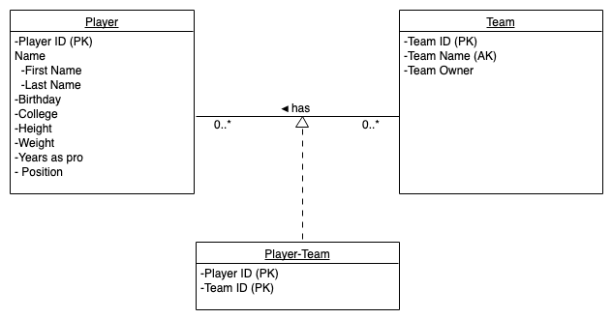

UML design for project

EER from MYSQL:

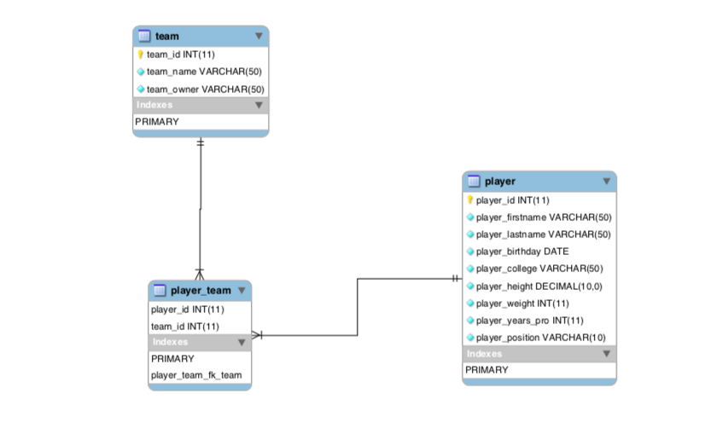

Brief step-by-step description of user interaction with our application:

1. User creates a fantasy football team within the application and gives it a name (represented by our teams table in the UML diagram), as well as specifying the name and the owner of the team. This employs the create tuples functionality of the application.
2. User looks up players from within the database and can sort them by position played. This employs the read tuples functionality of our application.
3. The user can add the player to a fantasy team (again, indicating the ability to create tuples in the application).
4. User can modify the team by deleting players (indicating the ability of our application to delete tuples).
5. User can modify their team by changing its name and by changing the owner of the team (illustrating the ability of our application to update tuples of data).

Technical Specifications:

Our plan is to include a front end representation of our application using html. We will be using a host language of Python and a Django based framework in order to create our user application, and will connect the SQL database to our project. For our data, we will retrieve a JSON of the active players in the NFL which contains various statistics such as their player ID on the NFL’s website, position, name, and other metrics such as height and weight. This information will be stored as records in our players table in our database.